**Class Project 6**

Use two images for each operation to do the following operations and write down their advantages and disadvantages and explain your results:

1. **Low pass filter (lena, camera):**

* LDLPF

**Algorithm:**

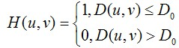

$D\left(u,v\right)={[{\left(u-\frac{P}{2}\right)}^{2}+{\left(v-\frac{Q}{2}\right)}^{2}]}^{1/2}$

Among them, D0 represents the radius of the passband. The calculation method of D(u,v) is the distance between two points, which can be easily obtained.

$G\left(u,v\right)=H(u,v)F(u,v)$

$G\left(u,v\right)$ processed by IFFT.

$H(u,v)$ is the filter.

1. Given an image $f(x,y)$ of size $m*n$. Choose appropriate filling parameters P and Q, generally let $P = 2m, Q = 2n$.
2. Fill the image $f(x, y)$ with 0, and get an image $fp(x, y)$ with an image size of P*Q after filling.
3. Multiply $(-1)^(x+y)$ by $fp(x,y)$ to move it to the center of the transformation (centralization).
4. Calculate the DFT of $fp(x, y)$ to get $F(u,v)$.
5. Generate a real, symmetric filter function $H(u, v)$ with size P*Q and centered at $(P/2, Q/2)$. Then multiply (matrix dot multiplication) to get $G(u,v) = H(u,v)F(u,v)$.
6. Take the inverse Fourier transform of $G(u, v)$, then take the real part, and then multiply it by $(-1)^(x+y)$ to perform the inverse center transform and finally get $gp(x,y)$.
7. Extract the $m*n$ area in the upper left corner of $gp(x,y)$, standardize the extracted part, and get the final result image $g(x,y)$.

Input: a unsigned char array that stores the source image data

Output: a unsigned char array that stores the output image data

for (int x = 0; x < Height; x++)

for (int y = 0; y < Height; y++)

$D_{0}$ = $\sqrt{{(y - width/2)}^{2}+{(x - height/2)}^{2}}$

if ( $D_{0}$ > radius)

src[x * width + y].x = 0;

else

src[x * width + y].y = 1;

**Results (including pictures):**

Result of processing “Lena.pgm”:

Source Image: Result after IDLPF: (radius = 30)

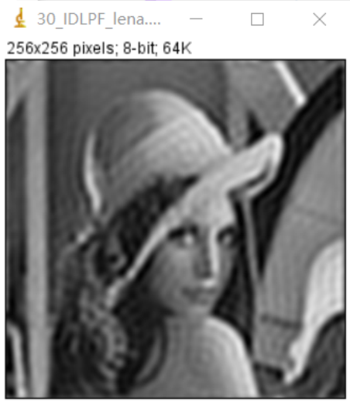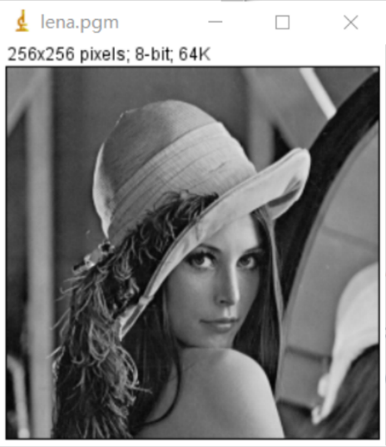

Result after IDLPF: Result after IDLPF: (radius = 80) (radius = 200)

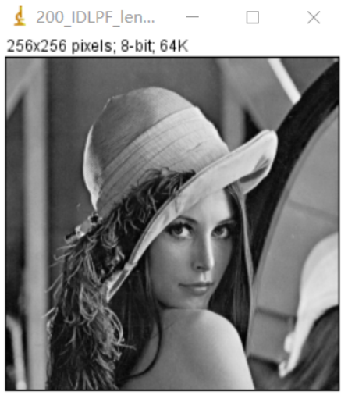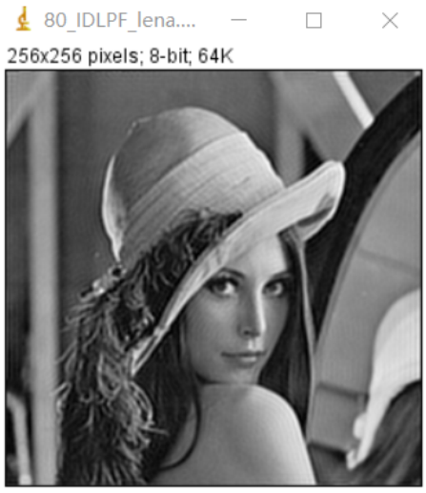

Result of processing “camera.pgm”:

Source Image: Result after IDLPF:

(radius = 30)

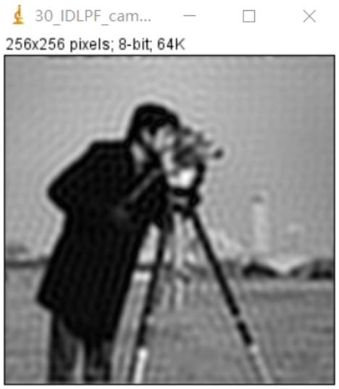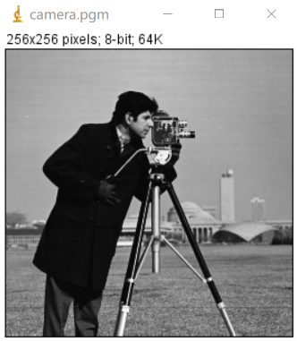

Result after IDLPF: Result after IDLPF: (radius = 80) (radius = 200)

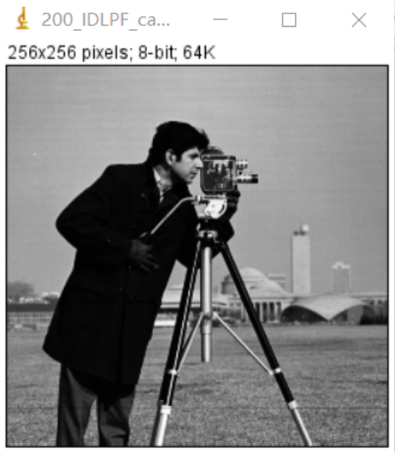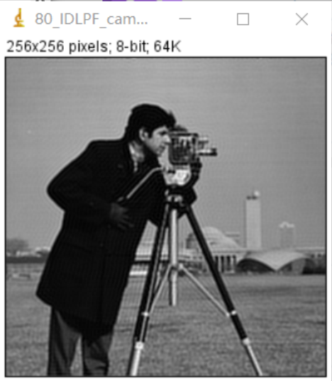

**Discussion:**

The results obtained using the low-pass filter are shown below. The low-pass filter filters out high-frequency components, so the image is blurred. Since the transition characteristics of the ideal low-pass filter are too steep, ringing occurs.

**Codes:**

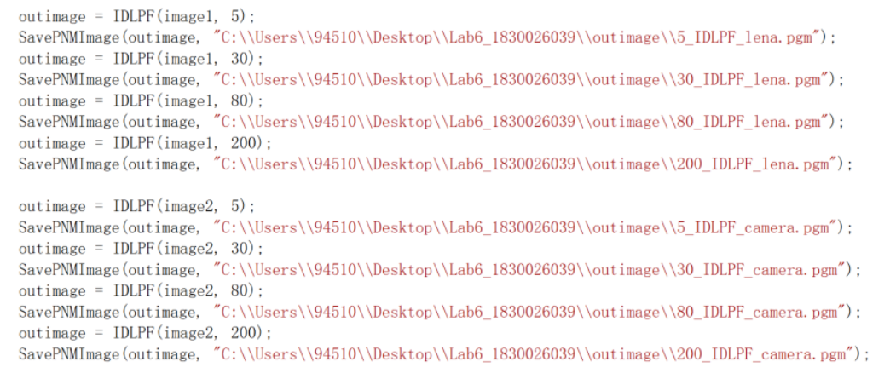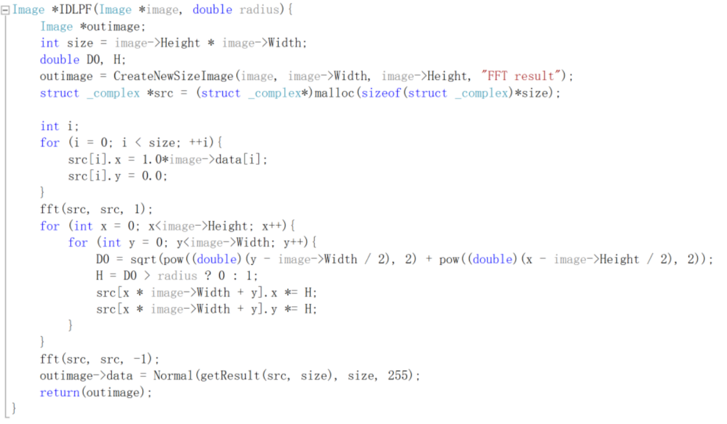

* BLPF

**Algorithm:**

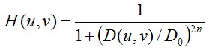

$D\left(u,v\right)={[{\left(u-\frac{P}{2}\right)}^{2}+{\left(v-\frac{Q}{2}\right)}^{2}]}^{1/2}$

Input: a unsigned char array that stores the source image data

Output: a unsigned char array that stores the output image data

for (int x = 0; x < Height; x++)

for (int y = 0; y < Height; y++)

=

H = $\frac{1.0}{(1+{(\frac{D_{0}}{radius})}^{2n})}$

src[x * width + y].x *= H;

src[x * width + y].y *= H;

**Results (including pictures):**

Result of processing “Lena.pgm”:

Source Image: Result after BLPF: (radius = 30)

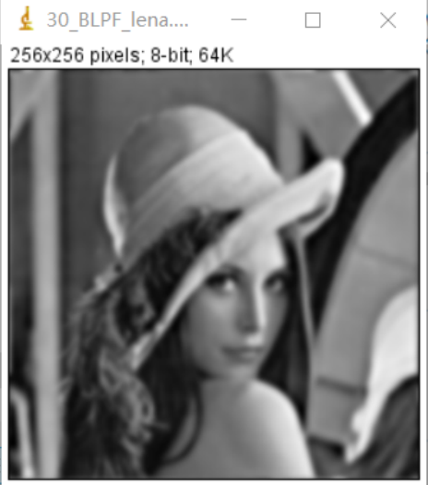

Result after BLPF: Result after BLPF: (radius = 80) (radius = 200)

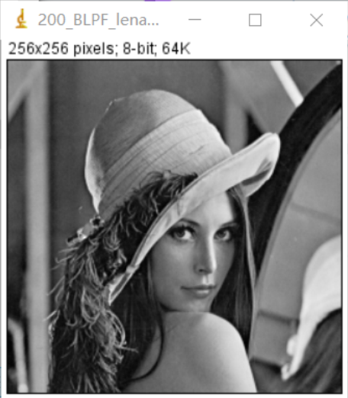 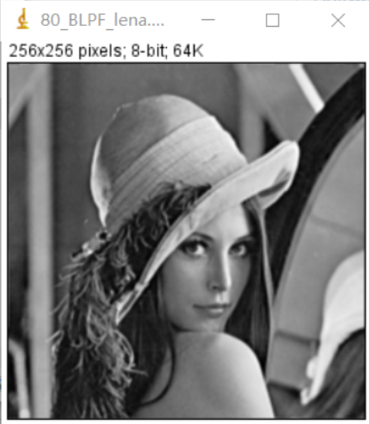

Result of processing “camera.pgm”:

Source Image: Result after BLPF:

(radius = 30)

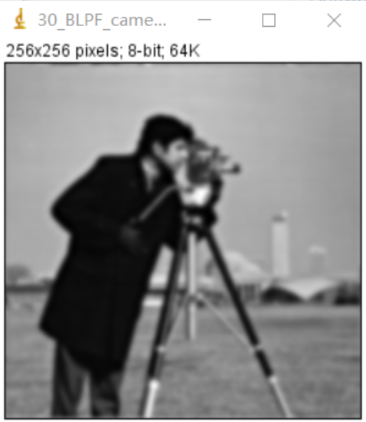

Result after BLPF: Result after BLPF: (radius = 80) (radius = 200)

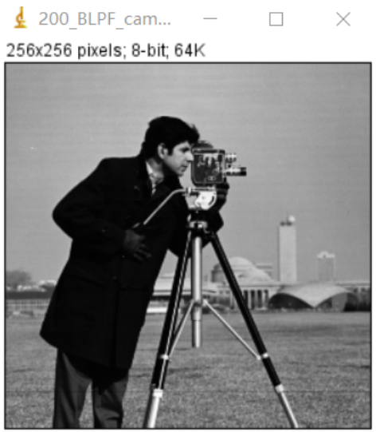 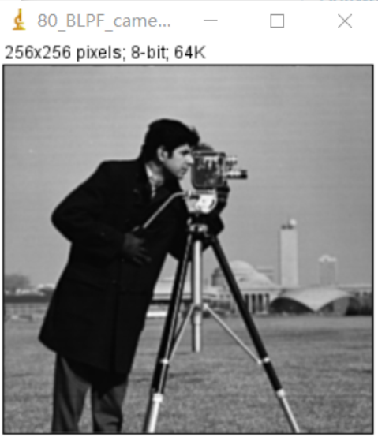

**Discussion:**

Butterworth low-pass filter. After filtering with the Butterworth low-pass filter, the result is different from the ideal low-pass filter. The smooth transition of the blur is a function of the increase of the cut-off frequency. In addition, there is no "ringing" in any image processed by this BLPF, which is due to the smooth transition between low frequency and high frequency of this filter.

**Codes:**

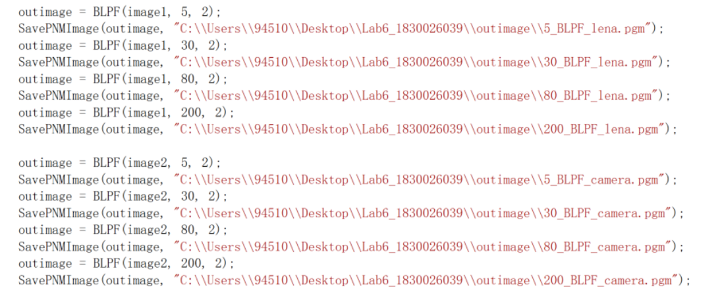 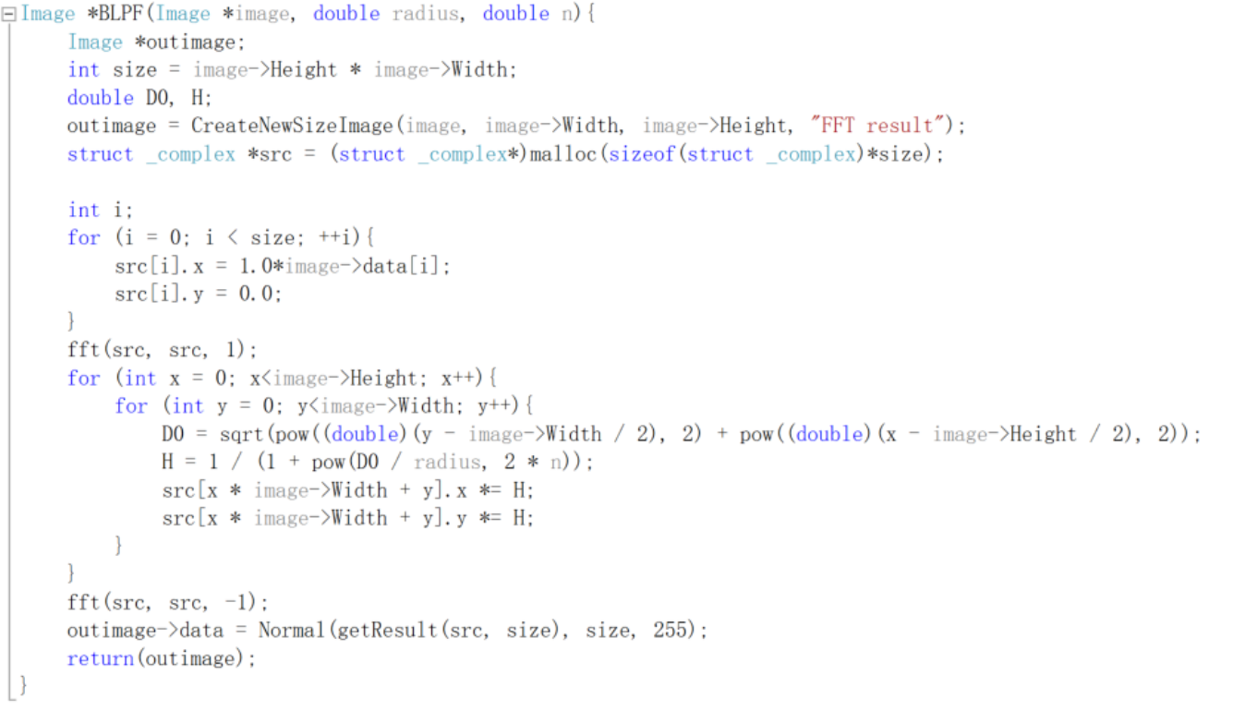

* GLPF

**Algorithm:**

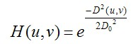

$D\left(u,v\right)={[{\left(u-\frac{P}{2}\right)}^{2}+{\left(v-\frac{Q}{2}\right)}^{2}]}^{1/2}$

Input: a unsigned char array that stores the source image data

Output: a unsigned char array that stores the output image data

for (int x = 0; x < Height; x++)

for (int y = 0; y < Height; y++)

=

H = $e^{\frac{-D_{0}}{2n^{2}} }$

src[x * width + y].x *= H;

src[x * width + y].y *= H;

**Results (including pictures):**

Result of processing “Lena.pgm”:

Source Image: Result after GLPF: (radius = 30)

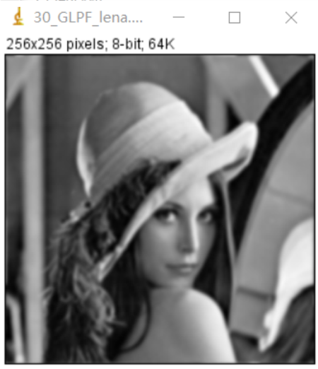

Result after GLPF: Result after GLPF: (radius = 80) (radius = 200)

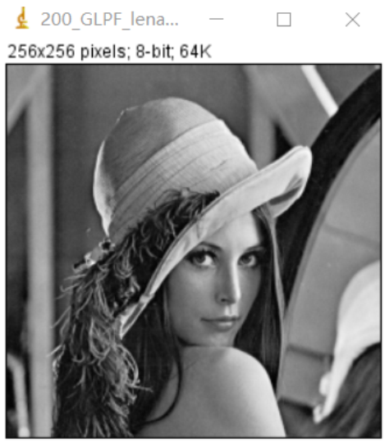 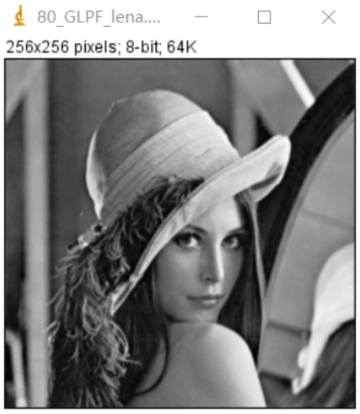

Result of processing “camera.pgm”:

Source Image: Result after GLPF:

(radius = 30)

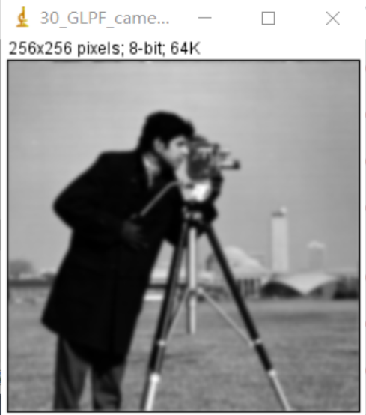

Result after GLPF: Result after GLPF: (radius = 80) (radius = 200)

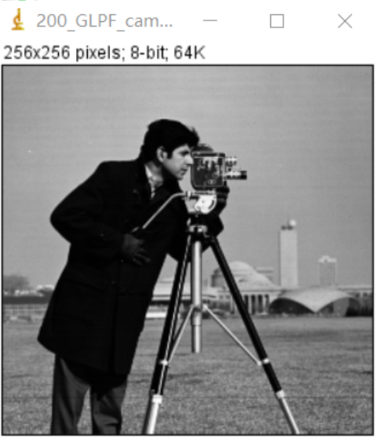 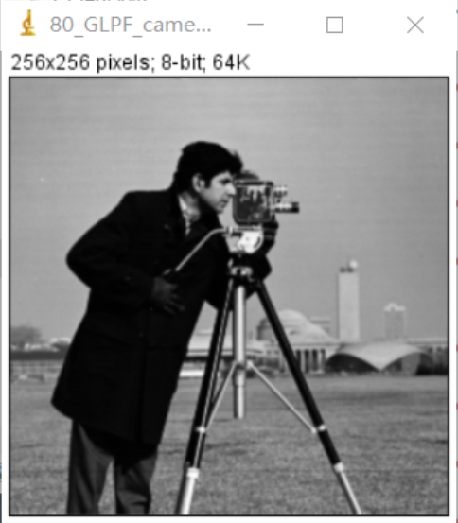

**Discussion:**

The width of the Gaussian filter (determining the degree of smoothing) is characterized by the parameter n, and the relationship between n and the degree of smoothing is very simple. The larger the n, the wider the frequency band of the Gaussian filter and the better the smoothness. By adjusting the smoothness parameter n, a compromise can be made between excessive blurring of image features (over-smoothing) and excessive undesired abrupt changes (under-smoothing) caused by noise and fine texture in the smooth image.

**Codes:**

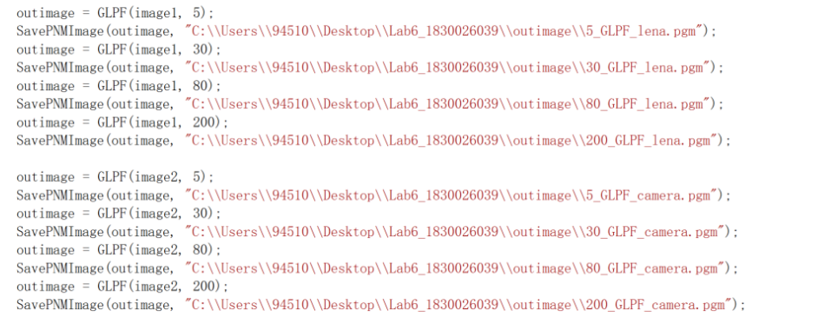 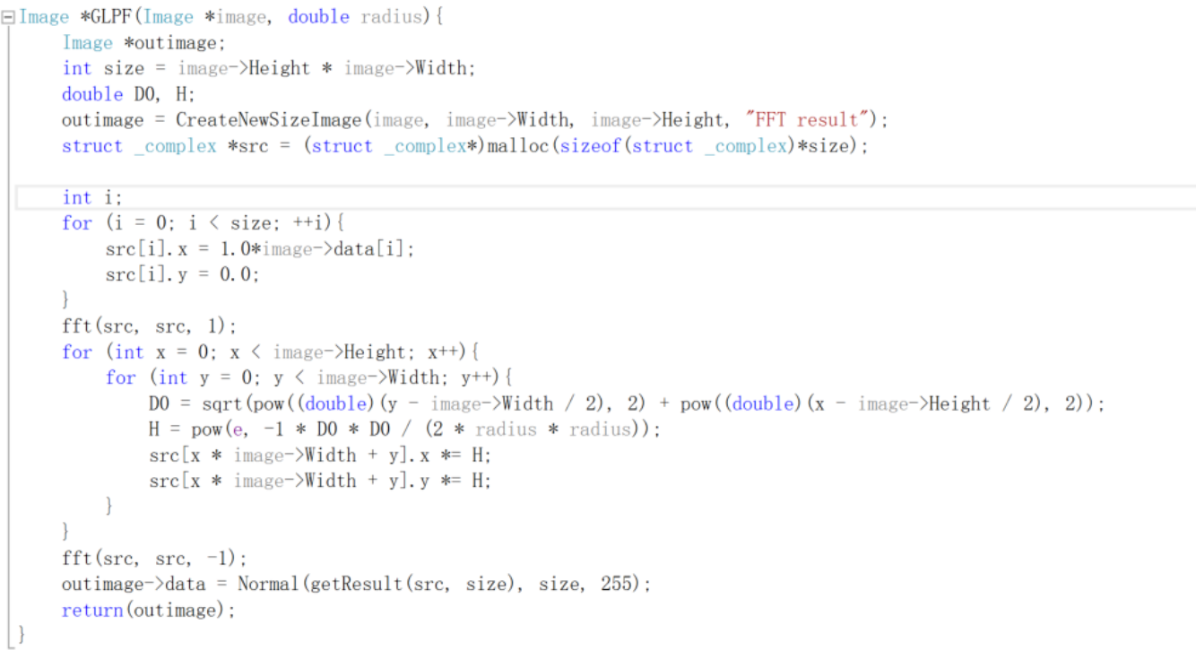

1. **HPF and thresholding sharpen (fingerprint1, fingerprint2):**

**Algorithm:**

Use IDHPF:

Algorithm is same as IDLPF.

Input: a unsigned char array that stores the source image data

Output: a unsigned char array that stores the output image data

for (int x = 0; x < Height; x++)

for (int y = 0; y < Height; y++)

$D_{0}$ = $\sqrt{{(y - width/2)}^{2}+{(x - height/2)}^{2}}$

if ( $D_{0}$ > radius)

src[x * width + y].x = 1;

else

src[x * width + y].y = 0;

let thresholding = 100

if (data > 100)

data = 255

else

data = 0

**Results (including pictures):**

Result of processing “fingerprint1.pgm”:

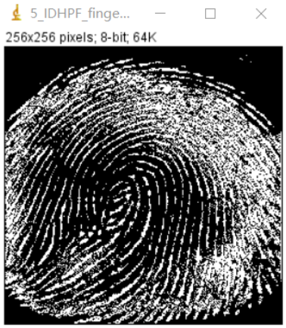Source Image: Result after IDHPF: (radius = 5)

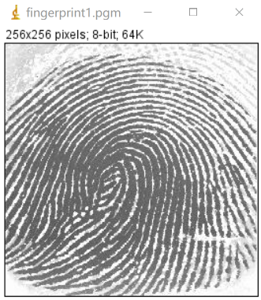

Result after IDHPF: Result after IDHPF: (radius = 30) (radius = 80)

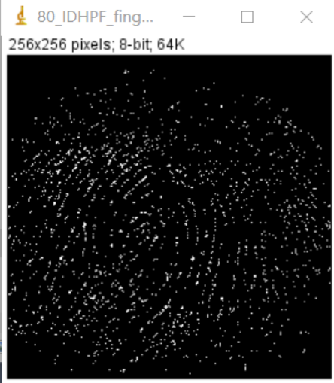 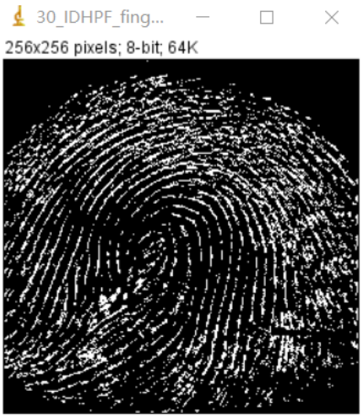

Result of processing “fingerprint2.pgm”:

Source Image: Result after IDHPF:

(radius = 5)

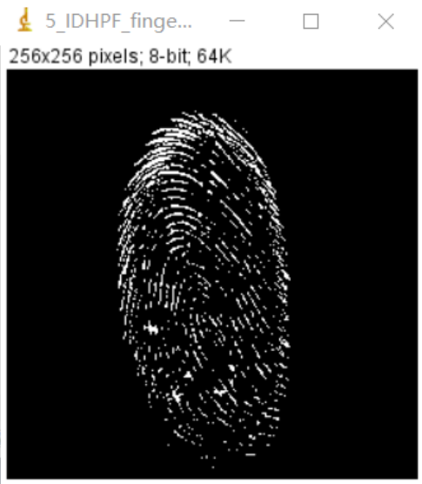 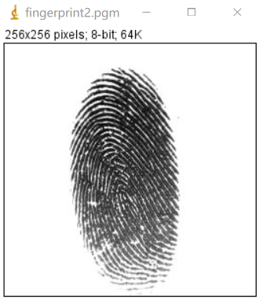

Result after IDHPF: Result after IDHPF: (radius = 30) (radius = 80)

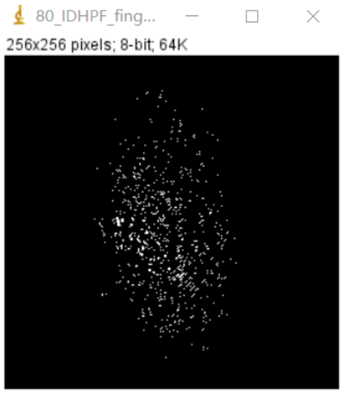 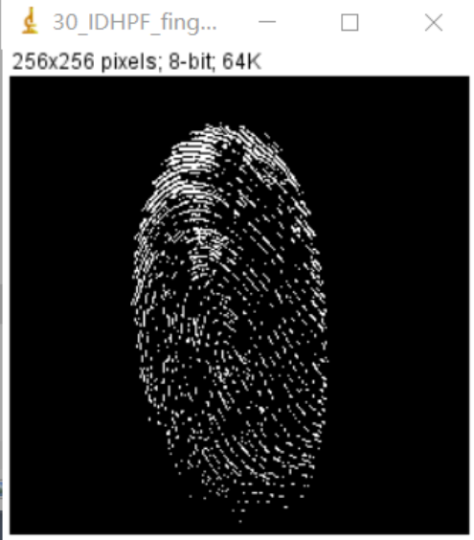

**Discussion:**

It is to use the frequency characteristics of the filter to allow high frequencies to pass, but low frequencies cannot pass. It is like setting a threshold in the frequency domain. Each frequency component in the frequency domain has an "amplitude", and the filter is like giving different frequency components. This amplitude is multiplied by different gains, and the high-pass is like the high-frequency part with a gain of 1, and the low-frequency part with a gain of 0.

**Codes:**

